Practical
SUMMARY:-
Matrix Chain Multiplication is implemented using Dynamic Programming. The main goal is to find the best order of multiplying a sequence of matrices so that the minimum number of scalar multiplications is performed. The algorithm stores previously calculated results in a table and avoids repeated calculations.
Output
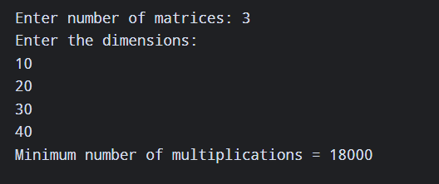
Time Complexity:
Case | Time Complexity
Best Case | O(n³)
Average Case | O(n³)
Worst Case | O(n³)
Three nested loops are used to calculate the minimum multiplication cost.
Conclusion-
Thus, the Matrix Chain Multiplication problem was successfully implemented using Dynamic Programming. The algorithm finds the optimal order of matrix multiplication and minimizes the total number of scalar multiplications.

